The Evolution of Vernalisation in Flowering Plants

In flowering plants, sensing environmental conditions and regulating flowering time is the key to maximising the potential for reproduction. Flowering too early can result in damage to the delicate reproductive organs during unseasonal cold snaps, while flowering too late means the plant can miss out on favourable growing conditions during spring. Crop planting schedules are planned specifically to exploit mechanisms for responding to these environmental cues, such as vernalisation, to maximise yield. While different plants respond differently on a genetic level, the overall response is regulation of the time a plant transitions from a vegetative growth state to a flowering one.

The Vernalisation Response

Vernalisation is characterised by a prolonged (i.e. greater than ten days) exposure to low but non-freezing temperatures. Vernalisation (from the Latin *vernum*, meaning *spring*), and its effect on harvest time and crop yield has been a central research focus of the plant biology community for over 150 years (Klippart 1857; Gassner 1918). The temperature at which the vernalisation response is triggered is dependent on the plant species and individual cultivar (see Table 1). It is theorised that the threshold temperature that triggers a vernalisation response can be calculated by examining the rate of plant growth under a range of temperatures, extrapolating the curve then selecting a temperature a few degrees above the inferred basal temperature (Angus et al. 1980). Sugar beet (*Beta vulgaris*) and carrot (*Daucus carota*) must be exposed to vernalisation before the plant is able to flower (an *absolute* vernalisation response) (Dijk et al. 1997; Alessandro et al. 2013). However, in wild populations, those growing in warmer temperatures require less exposure to vernalisation to trigger flowering. Where vernalisation is not essential for the transition to flowering (a *facultative* vernalisation response), such as in *Arabisopsis* *thaliana* (*Arabidopsis*) (Burn et al. 1993; Bastow et al. 2004), narrow leaf lupin (*Lupinus Augustifolius*) (Landers 1995), and winter wheat (*Triticum aestivum*) and barley (*Hordeum vulgare*) (Trevaskis et al. 2006; Oliver et al. 2009), the transition to flowering is triggered sooner than a plant which is unexposed (Sheldon et al. 2000). The genetic pathways of the vernalisation response are family-specific: not just between dicotyledonous (dicots) and monocotyledonous species (monocots), but also within different dicots (Reeves et al. 2007). Despite these differences, the gene pathways in vernalisation responsive plant species are epigenetic in nature (i.e. a vernalisation sensitive variety of a plant species will resulting in expression of a different phenotype when exposed to vernalisation conditions). These epigenetic changes are reset in the next generation.

In *Arabidopsis* and other dicots, the shoot tip is located at the crown of the plant and contains the shoot apical meristem (SAM) and is composed of a collection of pluripotent stem cells that slowly divide and differentiate into the various progenitor cells necessary for vegetative tissue growth (Meyerowitz 1997; Fletcher 2002). In *Poa pratensis* (Kentucky Bluegrass) and other monocots, the location of the pluripotent stems cells are in the basal meristem at the bottom of the plant, just above the soil line (Etter 1951). Regardless of location, after floral induction, the types of progenitor cells that the pluripotent meristem cells produce changes into those progeny cells necessary for the creation of tissues and structures for flowering. In 1962, Wellensiek (Wellensiek 1962) showed that in a number of plants with a SAM, moving vernalised shoot stock to non-vernalised root stock resulted in a vernalised plant. Similarly, moving non-vernalised shoot stock to vernalised root stock did not result in an expressed vernalised phenotype, meaning that while other organs may respond to vernalisation conditions, the most profound location for phenotypic expression of vernalisation in dicots is the shoot tip containing the SAM. Presumably, a similar effect would be seen in monocots, where grafting a basal meristem of a vernalised plant onto non-vernalised root stock would result in an expressed phenotype showing exposure to vernalisation, and vice versa. However, the literature is not clear in this regard.

Vernalisation in *Arabidopsis* *thaliana*

In *Arabidopsis*, the MADS-box (MCM1, AGAMOUS, DEFICIENS, and SRF, serum response factor) (Riechmann & Meyerowitz 1997) transcription factor Flowering Locus C (FLC) is the key mediator in the transition to flowering. Before vernalisation, *FLC* expression is promoted by *FRIGIDA* (*FRI*), *FRIGIDA-LIKE 1* (*FRL1*) and *FRIGIDA-LIKE 2* (*FRL2*) (Werner et al. 2005). While *FLC* is expressed, it represses *Flowering Locus T* (*FT*) expression (Sheldon et al. 2000). In the *Arabidopsis* ecotype *Col*-0, during FLC expression, VERNALISATION 2 (VRN2) binds with CURLY LEAF (CLF), SWINGER (SWN) and FERTILIZATION-INDEPENDENT ENDOSPERM (FIE) to form the VERNALISATION 2 (VRN2)/Plant Homeo domain Polycomb Repression Complex 2 (PHD-PRC2) (Köhler & Villar 2008). This protein complex is constitutively bound to the *FLC* locus, maintaining the locus in an open conformational shape via H3 acetylation and allows transcriptional machinery to access the *FLC* regulatory sequence and promote *FLC* expression (De Lucia et al. 2008).

When the *Arabidopsis* cultivar *Col*-0 is exposed to non-freezing cold, this triggers expression of *VERNALISATION INSENSITIVE 3* (*VIN3*), *VERNALISATION 5/VIN3-LIKE* (*VEL1*) and *VERNALISATION 5* (*VRN5*). The translated proteins bind to the VRN2/PHD-PCR2 complex to promote histone H3 deacetylation and *VRN2*-directed trimethylation of H3K9 and H3K27 at the *FLC* locus (Sung & Amasino 2004), while simultaneously demethylating the H3K4 promotor region upstreamof *FLC* (Finnegan et al. 2005). This closes the conformational shape of *FLC*, blocking transcriptional machinery from accessing the locus, thereby repressing *FLC* expression (Finnegan & Dennis 2007). This epigenetic repression of *FLC* is stable and irreversible, ensuring the transition to a flowering state is permanent (Levy et al. 2002).

When the *FLC* locus is closed, *FLOWERING TIME* (*FT*), its homolog *TWIN SISTER OF FT* (*TSF*), and *SUPPRESSOR OF OVEREXPRESSION OF CONSTANS 1* (*SOC1*) can then be expressed. FT travels through the phloem and into meristem tissues (Corbesier et al. 2007). Once there, FT triggers floral induction by transitioning meristem cells to a reproductive state by promoting *LEAFY* (*LFY*) and *APETALA1* (*AP1*), the two primary promoters of floral apical meristem growth (Amasino 2004). These then cause pluripotent cells in the SAM to differentiate and divide into reproductive tissues and eventually flowering bodies.

There are another five homologs of FLC within *Arabidopsis* that are regulated by vernalisation. Expression of *MADS AFFECTING FLOWERING1* (*MAF1*)through *MAF4* are all downregulated by vernalisation, whereas *MAF5* is upregulated (Ratcliffe et al. 2003). Different isoforms of *MAF2* are expressed at different temperatures, with *maf2* mutants

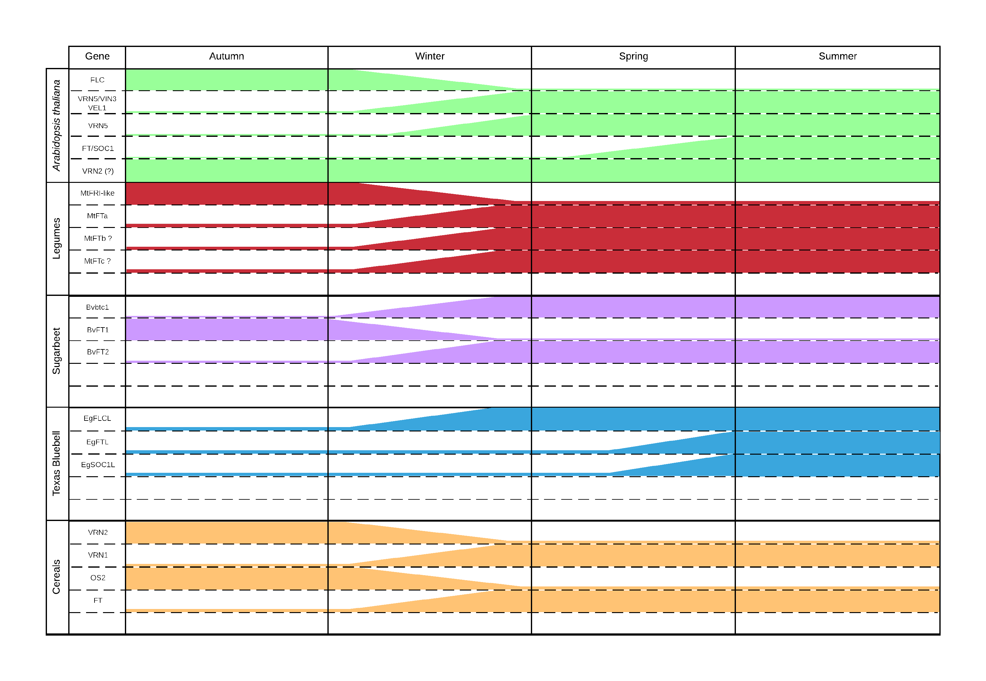

Figure 1 – Summary of genes expressed in several plant species after exposure to vernalisation conditions.

showing an inability to repress flowering at low temperatures (Airoldi et al. 2015). This indicates that while *FLC* is still the primary regulator of flowering time and main target of regulation by vernalisation, it does not act as the sole regulator. Modifications to genes upstream of *FLC* regulate its expression, not just *flc* mutants. Natural variations in *FRI* in *Arabidopsis* ecotypes resulting in low FRI levels have been shown to decrease the time to flowering, meaning the presence of *FRI* promotes expression of *FLC* (Werner et al. 2005). Similarly, *vin3* loss of function mutants are shown to lose the ability to detect cold, meaning the plant no longer responds to vernalisation (Sung & Amasino 2004).

Vernalisation Response in Legumes

There are a number of *Fabaceae* (legume) genera that respond to vernalisation. *Medicago truncatula* contains three classes of *FT* genes (*FTa* *FTb* and *FTc*) that are conserved across the *Fabaceae* but are not found in any other angiosperm (Hecht et al. 2011). Five *FT-like* genes exist in *M. truncatula*; *MtFTa1*, *MtFTa2*, *MtFTb1*, *MtFTb2* and *MtFTc* (Laurie et al. 2011). Of these, overexpression of *MtFTa1* occurs in the spring mutant of *M. tuncatula* (Putterill et al. 2013). But in the wild type, *MtFTa1* overexpression is only seen after exposure to vernalisation conditions (Jaudal et al. 2013). *Medicago* species also appear to lack an *Arabidopsis* *FLC* or *MAF* homolog (Hecht et al. 2005), but contains *MtFRI-like*. When *MtFRI-like* was transformed into the *Arabidopsis* variety Col-*0*, flowering was delayed, indicating *MtFRI-like* has a similar functional homology to *AtFRI* by promoting the expression of *FLC* (Chao et al. 2013).

Other members of the of *Fabaceae* also respond to vernalisation. The vernalisation response in pea (*Pisum*) has been known for some time (Reid & Murfet 1975). More recently, research in the *Lupinus* genus, (namely *L. albus*, *L. augustifolius* and *L. luteus*) has shown a similar vernalisation response (Gladstones & Hill 1969; Landers 1995). In both *Pisum* and *Lupinus*, similar to *Arabidopsis*, the decreased in time to flowering is proportional to the time the seedlings have been exposed to vernalisation conditions. While the exact mechanisms for this phenotypic response have not been confirmed in these genera, it could be surmised that homologs of the *MtFT* family will play a central role, similar to *Medicago*.

Even with the absence of MADS-box homologs to *FLC* and *MAF1* through *MAF5*, critical to the vernalisation response and flowering time in *Arabidopsis*, the *Fabaceae* are still able to response to vernalisation environmental cues, as seen in overexpression of *MtFTa1* and *MtFRI-like*. While these have been shown to be functional homologs in *Arabidopsis*, the exact mechanism of these regulators in legumes are yet to be characterised.

Vernalisation in Texas Bluebell

Texas Bluebell (*Eustoma* spp.) is an ornamental flowering plant native to the southern United States, Central America and the northern regions of South America. *Eustoma* have a similar vernalisation response to *Arabidopsis* and *L. augustifolius*, where the time to bolting is shortened in proportional to the amount of cold exposure (Pergola 1992). *Eustoma* *grandiflorum* contains homologs to *Arabidopsis* FLC, FT and SOC1 (EgFLCL, EgFTL and EgSOC1L respectively). EgFTL and EgSOC1L appear to be functional homologs of their *Arabidopsis* counterparts and are lowly expressed until restoration of inductive photoperiod post vernalisation, when the expression levels of EgFTL and EgSOC1L increase. However, EgFLCL appears to be lowly expressed during vegetative growth and only increases with the onset of vernalisation, the opposite of what is observed in *Arabidopsis* (Nakano et al. 2011). This may indicate that the function of EgFLCL is closer to that of MAF5 in *Arabidopsis* than other MADS-box containing transcripts such as FLC or MAF2-5 (Ratcliffe et al. 2003). So rather than directly repressing the expression of *EgFTL*, *EgFLCL* may restrict the expression of a gene target which in itself repressed *EgFTL* in *Eustoma*.

Vernalisation in Sugar beet

Sugar Beet (*Beta vulgaris* ssp. *Vulgaris*) is cropped for its large sucrose rich root organ. Photothermal induction (i.e. exposure to vernalisation conditions followed by increased day length) is necessary for flowering (Owen et al. 1940). Because of an absolute vernalisation requirement for flowering, breeders have selected for phenotypes that maintain the vegetative and root growth state so as to maximise root yield. Recent studies have characterised the molecular mechanisms underpinning the vernalisation response in beet as distinct from other species (Pin et al. 2012). Two paralogous *Flowering Locus T* (*FT*)genes, *BvFT1* and *BvFT2*, central to the regulation of flowering, are controlled by *BOLTING TIME CONTROL 1* *FLOWERING TIME 1* (*FT1*) is responsible for regulating *FLOWERING TIME 2* (*FT2*),(Pin et al. 2010). Rather than a single *FT* gene responsible for triggering flowering time controlled by FLC, as seen in *Arabidopsis* (*BvBTC1*). In biannual wild type sugar beet, those ecotypes that occur further north contain a greater composition of is the recessive allele of *Bvbtc1*, which produces a phenotype with an absolute vernalisation requirement. As the latitude increases and the location is closer to the warmer Mediterranean climate, the requirement for vernalisation to flower is diminished as the dominant *BvBTC1* is the more frequent allele (Dijk et al. 1997). While the vernalisation pathway in *B. vulgaris* is distinct from *A. thaliana*, it also containsa number of homologous pathways, including the photoperiod pathway (Chia et al. 2008) and the autonomous pathway (Abou-Elwafa et al. 2011). However, these pathways are yet to be fully characterised in sugar beet.

Vernalisation in Cereals

Monocots, such as bread wheat (*Triticum aestivum*), barley (*Hordeum vulgare*) and *Brachypodium distachyon* (a model monocot) have a vernalisation pathway that differs again *Arabidopsis* and other dicots. While there are a number of genetic mechanisms conserved between monocots and dicots, the most notable difference is the absence of a known homolog for AtFLC. Instead, the interplay between *VRN1* (a MADS-box transcription factor), *VRN2* (which in cereals is distinct from *AtVRN2*) (Yan et al. 2004) and *VRN3* (a homolog of *AtFT*) (Trevaskis, Hemming, et al. 2007), regulates the response to vernalisation.

In cereals, VRN1 serves two purposes: as a regulator of *VRN2* expression and as a key meristem identity gene (Trevaskis, Tadege, et al. 2007). Recessive alleles of VRN1 in winter wheats (*vrn1-A1|B1|D1*) require vernalisation for expression, otherwise a late flowering phenotype is expressed. Spring wheats have dominant alleles of these genes and therefore are naturally early flowering (Trevaskis et al. 2003). During vernalisation of winter barley, H3K27 demethylation and trimethylation H3K4me3 occurs at the *HvVRN1* locus. This opens the histone conformational shape, allowing *VRN1* expression (Oliver et al. 2009). Similar to *FLC* in *Arabidopsis*, this epigenetic change is stable, but in winter barley, the shape change permits (rather than restricts) access to the *HvVRN1* locus.

Similar to *Arabidopsis* where FLC represses *FT* expression, expression of HvVRN2represses the expression of *HvVRN3* (Ream et al. 2014). Prior to vernalisation of winter cereals, the floral repressor ODDSOC2 (OS2) is also present at high levels, interacting alongside HvVRN2 to maintain the cereal in a vegetative growth state (Greenup et al. 2010). After vernalisation, increased levels of HvVRN1 repress *HvVRN2* expression. Low HvVRN2 levels in turn promote *HvVRN3* expression, triggering the transition of the winter barley to flowering (Trevaskis et al. 2006). Exposure to vernalisation conditions and the presence of HvVRN1 also stably inhibits the expression of *OS2*. Lower levels of OS2 promote the expression of *FPF1*, which in turn promotes the transition to a flowering state. This mechanism of VRN1 repressing *VRN2* expression is seen in spring cereals, as the VRN1 allele is expressed without the need for vernalisation.

*VRN3* is the downstream target of VRN2. After VRN1 represses *VRN2* expression (after vernalisation has taken place in the case of winter cereals), decreasing levels of VRN2 allows the expression of the *AtFT* homolog, *VRN3.* VRN3 then interacts with VRN1, which in addition to a VRN2 repressor is also a promoter of meristem identity and flowering, the cereal can then transition from vegetative growth to a reproductive state.

While there are a number of parallels between vernalisation response in *Arabidopsis* and cereals, in terms of being epigenetic in nature and some sequence homology, this is where the parallels end. While the lack of an FLC equivalent, the dual acting role of VRN1 as both a meristem identity factor that promotes flowering and a represser of *VRN2* expression, demonstrates a divergence from the dictots with regard to the genetic response to vernalisation.

Vernalisation in the *Asteraceae*

While much research has into the vernalisation response in major crop species and *Arabidopsis*, current research regarding the vernalisation response in safflower, and indeed, other members of the *Asteraceae* family (one of the largest and most diverse of the flowering plant families) is scarce. Early research in lettuce (*Lactuca sativa*) observed that germinated seeds that were vernalised prior to planting responded by bolting up to four weeks earlier than unvernalised seeds (Figure 2) (Gray 1942; Warne 1947; Rappapport et al. 1956). Later studies indicated that in response to vernalisation temperature cues and extending day length, However, without these cues, lettuce still transitioned to flowering, indicating a *facultative* vernalisation response, similar to *Arabidopsis* (Waycott 1995). This research was, however, restricted only to the physiological response.

Chicory (*Cichorium intybus*) is an *Asteraceae* with an absolute vernalisation requirement. *CiFL1*, a MADS-box transcription factor with significant sequence homology to *AtFLC*, is expressed during vegetative growth. Similar to *Arabidopsis*, when exposed to vernalisation conditions, chicory represses the expression of *CiFL1* (Périlleux et al. 2013). When *CiFL1* was transformed into *Arabidopsis* and over expressed, the mutants showed a significant

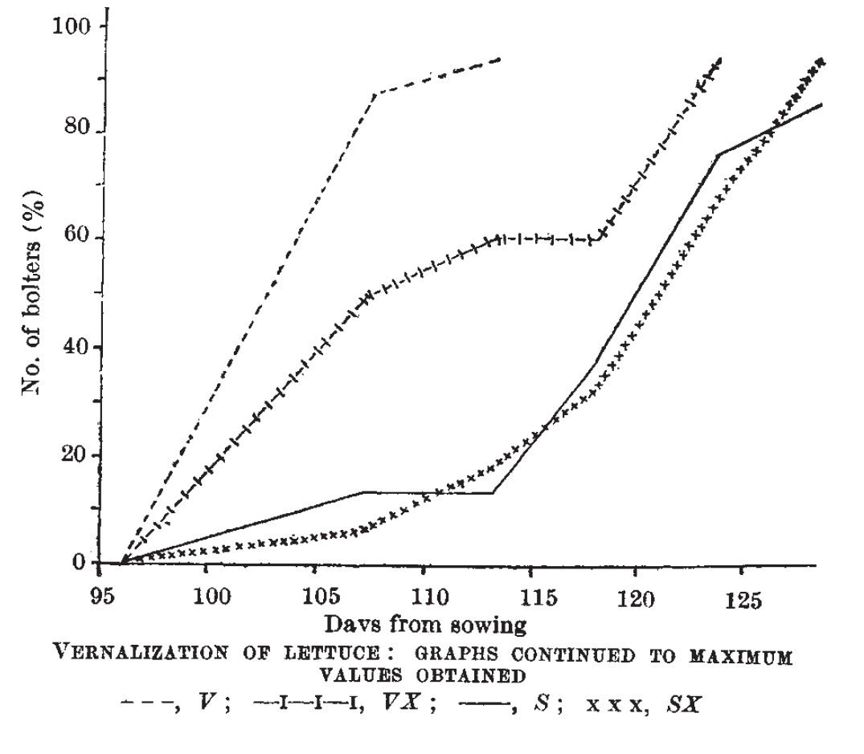

Figure 2 – The effect of vernalisation on days to bolting in lettuce, taken from (Warne 1947)

delay in onset of flowering, regardless of vernalisation exposure, indicating a similar molecular pathway effect between CiFL1 and AtFLC in *Arabidopsis*. However, after the vernalised plant is returned to warm growing conditions, *CiFL1* expression increases again, showing this repression to be transient, not stable like in *Arabidopsis*.

Early studies in safflower indicate a relationship between photoperiod, vernalisation and a decrease in the time to flowering in some safflower varieties (Zimmerman 1973). While a FLC homologue may be present in many species (Reeves et al. 2007), based on what is seen in *Eustoma*, there may be no functional homology of FLC in *Asteraceae*, with any homology to FLC in other species is in sequence only. Limited availability of genetic resources for the *Asteraceae* makes characterisation of the molecular pathways for vernalisation within this genus challenging. As further resources become available and are better annotated, these mechanisms by which vernalisation, and other factors, affect flowering time will be better understood.

Phylogenetic Analysis of Vernalisation Responsive Species

Approximately 34 million years ago, there was a geological transition from the tropical Eocene age to the modern, temperate Oligocene (Silva & Jenkins 1993; Speelman et al. 2009). This resulted in a drop in the minimum mean winter temperature after the Eocene/Oligocene (E/O) boundary (Ivany et al. 2000). Using marine temperatures as a proxy for land temperatures, this drop resulted in a mass extinction event. Species that could not adapt to the cooler, temperate climate perished, while species that could respond to the extended periods of winter cold survived. These species have then diversified

Out of all of the flowering plant species investigated, within the dicots, only the *Fabaceae* lack an *FLC* homolog. The closest family to the *Fabaceae* is the *Brassicales* <difference in evolutionary time>, containing *Arabidopsis*.Perhaps the Rosids diverged from the other flowering clades in terms of the way that vernalisation effects FLC expression, with the *Fabaceae* diverging even further, losing *FLC* altogether while still maintaining a response to vernalisation.

The monocots are the furthest removed from the other investigated families <difference in evolutionary time>, which explains not only the physical and physiological differences between monocots and dicots, but also the different genetic mechanisms that control the vernalisation response in cereals.

Within the *Asterids*, the differences between the genetic mechanisms of the *Caryphyllales* when compared to the *Gentianales* can be explained by the idea that the *Caryphyllales* represent an primitive lineage of flowering plants (Wang 2010), where the *Gentianales* and the *Asterales* have diverged from a common ancestor. It will be interesting to see if members of the *Asterales*, being another ancient flowering plant lineage, have genetic mechanisms relating to the vernalisation response that resemble the *Caryphyllales* or the *Gentianales*.

* + Eustoma and Asteraceae reasonably close, hence both containing FLC? Make an inference that this is the case. Anything on sunflower/lettuce and FLC?
    - Which is older? Eustoma or Asteraceae?
      * <http://tolweb.org/Gentianales/20724>
      * <http://tolweb.org/Asteraceae/20780>

The Rise of Whole Genomic Sequencing and RNASeq

In the last 15 years, Next Generation Sequencing (NGS) has expanded the quantity and quality of information available to levels never before seen, with data available in less time and at an ever decreasing cost (Wetterstrand 2014). This has allowed genomes and transcriptomes to be generated at an almost routine frequency. The hope was that this expansion of data generation capability would quickly allow the understanding of complex genetic pathways. However, the opposite has been observed. Mining these data sets has generated even further questions as to the mechanisms that underlay even some of the most well understood genetic pathways

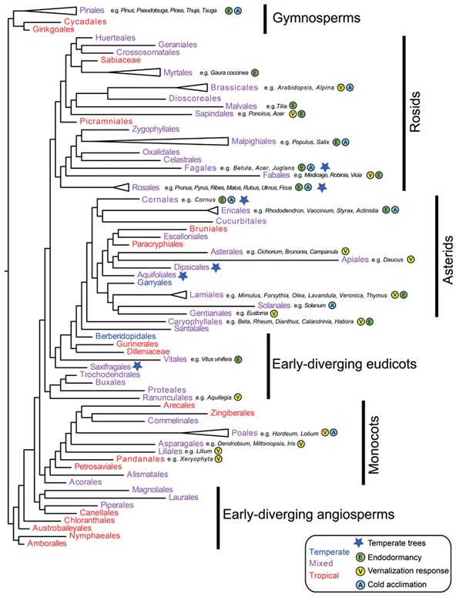

Figure 3 – Phylogenetic tree of different seed producing plant families, taken and adapted from (Preston & Sandve 2013). Individual members of represented families examined in this review have been indicated with a grey box around the family name and attributes. Approximate ages of families taken from (Stevens 2001)

|  |  |  |
| --- | --- | --- |
| **Family** | **Age (million years old)** | **Location** |
| Asterales |  | http://www.mobot.org/MOBOT/research/APweb/orders/ asteralesweb.htm#Asterales |
| Brassicales |  | http://www.mobot.org/MOBOT/research/APweb/orders/ brassicalesweb.htm#Brassicales |
| Caryophyllales |  | http://www.mobot.org/MOBOT/research/APweb/orders/ caryophyllalesweb.htm#Caryophyllales |
| Fabales |  | http://www.mobot.org/MOBOT/research/APweb/orders/ fabalesweb.htm#Fabales |
| Gentianales |  | http://www.mobot.org/MOBOT/research/APweb/orders/ gentianalesweb.htm#Gentianales |
| Poales |  | http://www.mobot.org/MOBOT/research/APweb/orders/ poalesweb.htm#Poales |

Table 1 – Approximate ages of investigated families. (Stevens 2001). Approximate age of family has been derived from the references in the age section of site where possible.

Conclusions

In most plant species, the presence of a vernalisation response has been known for quite some time. While the phenotypic response to vernalisation is consistent between different facultative or absolute vernalisation species, the underlying genetic mechanisms differ substantially. During vernalisation, in *Arabidopsis*, FLC expression is repressed via modification to histone methylation and closing of the FLC locus, allowing the expression of FT and downstream genes. However, in barley, repression of VRN2 by VRN1 allows the expression of the FT homolog VRN3, allowing the transition of barley to flowering. Sugar beet has a different mechanism again, expressing two counteracting FT homologs (BvFT1 and BvFT2). It has also been shown that while both *Eustoma* and *Arabidopsis* both express homologs of FLC, its action in *Eustoma* is the opposite in the vernalisation response when compared to *Arabidopsis*. Perhaps the role of FLC (and other MADS-box transcription factors) as a repressor of FT is unique only to the *Brassicaceae*?

In the plant varieties above that respond to vernalisation, FT (or its variants) are expressed in true leaf tissue, with the downstream targets expressed in the shoot apical meristem. While the downstream effects of extended cold exposure can be observed in the phenotypic vernalisation response, the mechanisms of how plants detect cold in the first place is still poorly understood and difficult to elucidate. It was believed that with the rapid expansion of gene expression analysis, these mechanisms would become clear. But while this technology has provided an amazing insight into, such fundamental questions such as the mechanisms that plants use to detect exposure to cold are still yet to be answered. But perhaps there is another factor in play. In all the examples of vernalisation of plants examined, while the gene affected by vernalisation has been repeatedly demonstrated, the specific mechanism that causes this effect in each case has not been identified. (Helliwell et al. 2015) have postulated that physical changes brought on by vernalisation conditions produce physical changes to the way DNA behaves in cells, essentially removing a quantity of the elasticity. This means that if a locus becomes open during the cold, it will remain open, allowing prolonged access to the site by genetic machinery. This may be another avenue of investigation to characterise the changes vernalisation has on all vernalisation responsive plants, not just *Arabidopsis*.

**References**

For submission to trends in Plant Science – NB: Mendeley referencing style for submission is IEEE

Abou-Elwafa, S.F. et al., 2011. Conservation and divergence of autonomous pathway genes in the flowering regulatory network of Beta vulgaris. *Journal of Experimental Botany*, 62(10), pp.3359–3374. Available at: http://jxb.oxfordjournals.org/content/62/10/3359.abstract.

Airoldi, C.A., McKay, M. & Davies, B., 2015. MAF2 Is Regulated by Temperature-Dependent Splicing and Represses Flowering at Low Temperatures in Parallel with FLM. *PLoS ONE*, 10(5), p.e0126516. Available at: http://dx.doi.org/10.1371%2Fjournal.pone.0126516.

Alessandro, M. et al., 2013. Molecular mapping of vernalization requirement and fertility restoration genes in carrot. *Theoretical and Applied Genetics*, 126(2), pp.415–423. Available at: http://dx.doi.org/10.1007/s00122-012-1989-1.

Amasino, R., 2004. Vernalization, Competence, and the Epigenetic Memory of Winter. *The Plant Cell Online*, 16(10), pp.2553–2559. Available at: http://www.plantcell.org/content/16/10/2553.short.

Angus, J.F. et al., 1980. Phasic development in field crops. I. Thermal response in the seedling phase. *Field Crop Research*, 3, pp.365–378.

Bastow, R. et al., 2004. Vernalization requires epigenetic silencing of FLC by histone methylation. *Nature*, 427(6970), pp.164–167. Available at: http://dx.doi.org/10.1038/nature02269.

Burn, J.E. et al., 1993. DNA methylation, vernalization, and the initiation of flowering. *Proceedings of the National Academy of Sciences*, 90(1), pp.287–291. Available at: http://www.pnas.org/content/90/1/287.abstract.

Chao, Y. et al., 2013. Expression of the alfalfa FRIGIDA-Like Gene, MsFRI-L delays flowering time in transgenic Arabidopsis thaliana. *Molecular Biology Reports*, 40(3), pp.2083–2090. Available at: http://dx.doi.org/10.1007/s11033-012-2266-8.

Chia, T.Y.P. et al., 2008. Sugar beet contains a large CONSTANS-LIKE gene family including a CO homologue that is independent of the early-bolting (B) gene locus. *Journal of Experimental Botany*, 59(10), pp.2735–2748. Available at: http://jxb.oxfordjournals.org/content/59/10/2735.abstract.

Corbesier, L. et al., 2007. FT Protein Movement Contributes to Long-Distance Signaling in Floral Induction of Arabidopsis. *Science*, 316(5827), pp.1030–1033. Available at: http://www.sciencemag.org/content/316/5827/1030.abstract.

Dijk, H. Van et al., 1997. Flowering time in wild beet (Beta vulgaris ssp. maritima) along a latitudinal cline. *Acta Oecologica*, 18(1), pp.47–60. Available at: http://www.sciencedirect.com/science/article/pii/S1146609X9780080X.

Etter, A.G., 1951. How Kentucky Bluegrass Grows. *Annals of the Missouri Botanical Garden*, 38(3), pp.293–375 CR – Copyright &#169; 1951 Missouri Botani. Available at: http://www.jstor.org/stable/2394639.

Finnegan, E.J. et al., 2005. The downregulation of FLOWERING LOCUS C (FLC) expression in plants with low levels of DNA methylation and by vernalization occurs by distinct mechanisms. *The Plant Journal*, 44(3), pp.420–432. Available at: http://dx.doi.org/10.1111/j.1365-313X.2005.02541.x.

Finnegan, E.J. & Dennis, E.S., 2007. Vernalization-Induced Trimethylation of Histone H3 Lysine 27 at FLC Is Not Maintained in Mitotically Quiescent Cells. *Current Biology*, 17(22), pp.1978–1983. Available at: http://www.cell.com/current-biology/abstract/S0960-9822(07)02087-8.

Fletcher, J.C., 2002. Shoot and Floral Meristem Maintenance in Arabidopsis. *Annual Review of Plant Biology*, 53(1), pp.45–66. Available at: http://dx.doi.org/10.1146/annurev.arplant.53.092701.143332.

Gassner, G., 1918. Beiträge zur physiologiischen Charakteristik sommer- und winterannueller Gewächse, insbesondere der Getreidepflanzen. *Zeitschrift für Botanik*, 10, pp.417–480.

Gladstones, J.S. & Hill, G.D., 1969. Selection for economic characters in Lupinus angustifolius and L. digitatus. 2. Time of flowering. *Australian Journal of Experimental Agriculture*, 9(37), pp.213–220. Available at: http://www.publish.csiro.au/paper/EA9690213.

Gray, S.G., 1942. Increased Earlieness of Flowering in Lettuce Through Vernalisation. *Journal of the Council for Scientific and Industrial Research, Australia*, 15(3), pp.211–212.

Greenup, A.G. et al., 2010. ODDSOC2 Is a MADS Box Floral Repressor That Is Down-Regulated by Vernalization in Temperate Cereals. *Plant Physiology*, 153(3), pp.1062–1073. Available at: http://www.plantphysiol.org/content/153/3/1062.abstract.

Hecht, V. et al., 2005. Conservation of Arabidopsis Flowering Genes in Model Legumes. *Plant Physiology*, 137(4), pp.1420–1434. Available at: http://www.scopus.com/inward/record.url?eid=2-s2.0-84892462923&partnerID=tZOtx3y1.

Hecht, V. et al., 2011. The Pea GIGAS Gene Is a FLOWERING LOCUS T Homolog Necessary for Graft-Transmissible Specification of Flowering but Not for Responsiveness to Photoperiod. *The Plant Cell Online*, 23(1), pp.147–161. Available at: http://www.plantcell.org/content/23/1/147.abstract.

Helliwell, C.A. et al., 2015. How is FLC repression initiated by cold? *Trends in Plant Science*, 20(2), pp.76–82. Available at: http://dx.doi.org/10.1016/j.tplants.2014.12.004.

Ivany, L.C., Patterson, W.P. & Lohmann, K.C., 2000. Cooler winters as a possible cause of mass extinctions at the Eocene/Oligocene boundary. *Nature*, 407(6806), pp.887–890. Available at: http://dx.doi.org/10.1038/35038044.

Jaudal, M. et al., 2013. Retroelement insertions at the Medicago FTa1 locus in spring mutants eliminate vernalisation but not long-day requirements for early flowering. *The Plant Journal*, 76(4), pp.580–591. Available at: http://dx.doi.org/10.1111/tpj.12315.

Klippart, J.H., 1857. An essay on the origin, growth, diseases, varieties etc of the wheat plant. *Annual Report of the Ohio State Board of Agriculture*, pp.562–720.

Köhler, C. & Villar, C.B.R., 2008. Programming of gene expression by Polycomb group proteins. *Trends in Cell Biology*, 18(5), pp.236–243. Available at: http://www.sciencedirect.com/science/article/pii/S0962892408000809.

Landers, K.F., 1995. Vernalization responses in narrow-leafed lupin (Lupinus angustifolius) genotypes. *Australian Journal of Agricultural Research*, 46(5), pp.1011–1025. Available at: http://www.publish.csiro.au/paper/AR9951011.

Laurie, R.E. et al., 2011. The Medicago FLOWERING LOCUS T Homolog, MtFTa1, Is a Key Regulator of Flowering Time1[C][W][OA]. *Plant Physiology*, 156(4), pp.2207–2224. Available at: http://search.proquest.com/docview/883393205?accountid=26957.

Levy, Y.Y. et al., 2002. Multiple Roles of Arabidopsis VRN1 in Vernalization and Flowering Time Control. *Science*, 297(5579), pp.243–246. Available at: http://www.sciencemag.org/content/297/5579/243.abstract.

De Lucia, F. et al., 2008. A PHD-Polycomb Repressive Complex 2 triggers the epigenetic silencing of FLC during vernalization. *Proceedings of the National Academy of Sciences*, 105(44), pp.16831–16836. Available at: http://www.pnas.org/content/105/44/16831.abstract.

Meyerowitz, E.M., 1997. Genetic Control of Cell Division Patterns in Developing Plants. *Cell*, 88(3), pp.299–308. Available at: http://www.sciencedirect.com/science/article/pii/S0092867400818681.

Nakano, Y. et al., 2011. Characterization of FLC, SOC1 and FT homologs in Eustoma grandiflorum: effects of vernalization and post-vernalization conditions on flowering and gene expression. *Physiologia Plantarum*, 141(4), pp.383–393. Available at: http://dx.doi.org/10.1111/j.1399-3054.2011.01447.x.

Oliver, S.N. et al., 2009. Vernalization-induced flowering in cereals is associated with changes in histone methylation at the VERNALIZATION1 gene. *Proceedings of the National Academy of Sciences*, 106(20), pp.8386–8391. Available at: http://www.pnas.org/content/106/20/8386.abstract.

Owen, F. V., Carsner, E. & Stout, M., 1940. Photothermal induction of flowering in suagr beets. *Journal of Agricultural Research*, 61, pp.101–124.

Pergola, G., 1992. The need for vernalization in Eustoma russellianum. *Scientia Horticulturae*, 51(1–2), pp.123–127. Available at: http://www.sciencedirect.com/science/article/pii/030442389290110X.

Périlleux, C. et al., 2013. A root chicory MADS box sequence and the Arabidopsis flowering repressor FLC share common features that suggest conserved function in vernalization and de-vernalization responses. *The Plant Journal*, 75(3), pp.390–402. Available at: http://dx.doi.org/10.1111/tpj.12208.

Pin, P.A. et al., 2010. An Antagonistic Pair of FT Homologs Mediates the Control of Flowering Time in Sugar Beet. *Science*, 330(6009), pp.1397–1400. Available at: http://www.sciencemag.org/content/330/6009/1397.abstract.

Pin, P.A. et al., 2012. The Role of a Pseudo-Response Regulator Gene in Life Cycle Adaptation and Domestication of Beet. *Current Biology*, 22(12), pp.1095–1101. Available at: http://www.cell.com/current-biology/abstract/S0960-9822(12)00394-6.

Preston, J.C. & Sandve, S.R., 2013. Adaptation to seasonality and the winter freeze. *Frontiers in plant science*, 4(JUN), p.167. Available at: http://www.scopus.com/inward/record.url?eid=2-s2.0-84892462923&partnerID=tZOtx3y1 [Accessed March 2, 2015].

Putterill, J. et al., 2013. FT genes and regulation of flowering in the legume Medicago truncatula. *Functional Plant Biology*, 40(12), pp.1199–1207. Available at: http://dx.doi.org/10.1071/FP13087.

Rappapport, L., Wittwer, S.H. & Tukey, H.B., 1956. Seed Vernalization and Flowering in Lettuce (Lactuca sativa). *Nature*, 178(4523), p.51. Available at: http://dx.doi.org/10.1038/178051a0.

Ratcliffe, O.J. et al., 2003. Analysis of the Arabidopsis MADS AFFECTING FLOWERING Gene Family: MAF2 Prevents Vernalization by Short Periods of Cold. *The Plant Cell Online*, 15(5), pp.1159–1169. Available at: http://www.plantcell.org/content/15/5/1159.abstract.

Ream, T.S. et al., 2014. Interaction of Photoperiod and Vernalization Determines Flowering Time of Brachypodium distachyon. *Plant Physiology*, 164(2), pp.694–709. Available at: http://www.plantphysiol.org/content/164/2/694.abstract.

Reeves, P.A. et al., 2007. Evolutionary Conservation of the FLOWERING LOCUS C-Mediated Vernalization Response: Evidence From the Sugar Beet (Beta vulgaris). *Genetics*, 176(1), pp.295–307. Available at: http://www.ncbi.nlm.nih.gov/pmc/articles/PMC1893026/.

Reid, J.B. & Murfet, I.C., 1975. Flowering in Pisum: the Sites and Possible Mechanisms of the Vernalization Response. *Journal of Experimental Botany*, 26(6), pp.860–867. Available at: http://jxb.oxfordjournals.org/content/26/6/860.abstract.

Riechmann, J.L. & Meyerowitz, E.M., 1997. MADS domain proteins in plant development. *Biological Chemistry*, 378, pp.1079–1118. Available at: //www.degruyter.com/view/j/bchm.1997.378.issue-10/bchm.1997.378.10.1079/bchm.1997.378.10.1079.xml.

Sheldon, C.C. et al., 2000. The molecular basis of vernalization: The central role of FLOWERING LOCUS C (FLC). *Proceedings of the National Academy of Sciences*, 97(7), pp.3753–3758. Available at: http://www.pnas.org/content/97/7/3753.abstract.

Silva, I.P. & Jenkins, D.G., 1993. Decision on the Eocene-Oligocene boundary stratotype. *Episodes*, 16(3), pp.379–382.

Speelman, E.N. et al., 2009. The Eocene Arctic Azolla bloom: environmental conditions, productivity and carbon drawdown. *Geobiology*, 7(2), pp.155–170. Available at: http://dx.doi.org/10.1111/j.1472-4669.2009.00195.x.

Stevens, P.F., 2001. Angiopserm Phylogeny Website (v13). Available at: http://www.mobot.org/MOBOT/research/APweb/.

Sung, S. & Amasino, R.M., 2004. Vernalization and epigenetics: how plants remember winter. *Current Opinion in Plant Biology*, 7(1), pp.4–10. Available at: http://www.sciencedirect.com/science/article/pii/S1369526603001419.

Trevaskis, B. et al., 2006. HvVRN2 Responds to Daylength, whereas HvVRN1 Is Regulated by Vernalization and Developmental Status. *Plant Physiology*, 140(4), pp.1397–1405. Available at: http://www.plantphysiol.org/content/140/4/1397.abstract.

Trevaskis, B. et al., 2003. MADS box genes control vernalization-induced flowering in cereals. *Proceedings of the National Academy of Sciences*, 100(22), pp.13099–13104. Available at: http://www.pnas.org/content/100/22/13099.abstract.

Trevaskis, B., Tadege, M., et al., 2007. Short Vegetative Phase-Like MADS-Box Genes Inhibit Floral Meristem Identity in Barley. *Plant Physiology*, 143(1), pp.225–235. Available at: http://www.ncbi.nlm.nih.gov/pmc/articles/PMC1761976/.

Trevaskis, B., Hemming, M.N., et al., 2007. The molecular basis of vernalization-induced flowering in cereals. *Trends in Plant Science*, 12(8), pp.352–357. Available at: http://www.sciencedirect.com/science/article/pii/S1360138507001562.

Wang, X., 2010. *The Dawn Angiosperms*, Berlin: Berlin. Available at: http://www.mobot.org/MOBOT/research/APweb/.

Warne, L.G.G., 1947. Vernalization of Lettuce. *Nature*, 159(4027), pp.31–32.

Waycott, W., 1995. Photoperiodic Response of Genetically Diverse Lettuce Accessions. *Journal of the American Society for Horticultural Science*, 120(3), pp.460–467. Available at: http://journal.ashspublications.org/content/120/3/460.abstract.

Wellensiek, S.J., 1962. Dividing Cells as the Locus for Vernalization. *Nature*, 195(4838), pp.307–308. Available at: http://dx.doi.org/10.1038/195307a0.

Werner, J.D. et al., 2005. FRIGIDA-independent variation in flowering time of natural Arabidopsis thaliana accessions. *Genetics*, 170(3), pp.1197–1207.

Wetterstrand, K., 2014. DNA Sequencing Costs: Data from the NHGRI Genome Sequencing Program (GSP). Available at: http://www.genome.gov/sequencingcosts/ [Accessed December 27, 2014].

Yan, L. et al., 2004. The Wheat VRN2 Gene Is a Flowering Repressor Down-Regulated by Vernalization. *Science*, 303(5664), pp.1640–1644. Available at: http://www.sciencemag.org/content/303/5664/1640.abstract.

Zimmerman, L.H., 1973. Effect of Photoperiod and Temperature On Rosette Habit in Safflower. , pp.80–81. Available at: https://dl.sciencesocieties.org/publications/cs/abstracts/13/1/80.